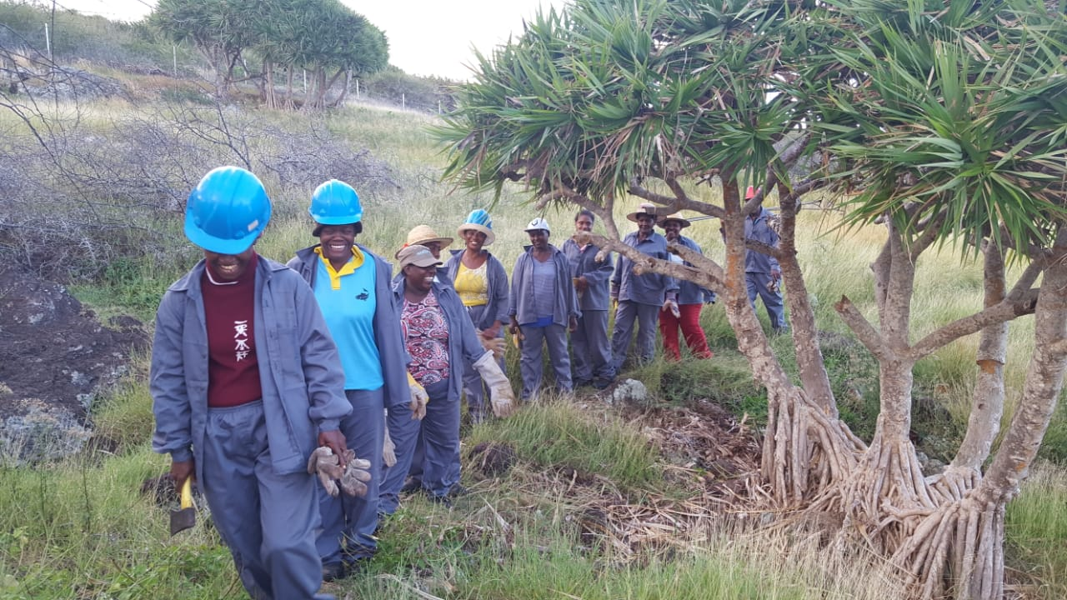
Introduction
This Toolkit presents the Guidelines on Ring Barking technique, showing how to eliminate invasive plants by using green initiatives and practices so as to reflect a more qualitative and ecological image. You are invited to use the Toolkit for yourself or for conducting group training.
This toolkit is being developed for those who are willing to embrace the path towards green ecological practices to discourage the use of chemical pesticides and other chemicals.
Utility of the toolkit
The toolkit shall act as a guide in setting direction and providing details on how to practice ring barking. It shall be used to spread knowledge and knowhow about the ring barking practices.
This training kit is based on the learning of a natural environment friendly method of eliminating invasive tree. The toolkit encompass the key aspects for complete elimination of invasive trees without cutting them down.

Equipment needed
In order for someone to successfully conduct this training or to practice ring barking techniques. The following equipment will be needed:
Equipment requirement for applying Ring Barking Techniques
Sn | Equipment | Quantity
1 | Chainsaw | 1
2 | Blade | 1
3 | Axe | 1
4 | Safety Shoes | 1 pair
5 | Safety Gloves | 1 pair
6 | Safety Overall (if Necessary) | 1

Defining the term Ring Barking Technique
What is Ring Barking?
Ring Barking consist of removing the outer layer (bark) of the plant to prevent it from transferring necessary nutrient and water from bottom (the root) of the plant to feed the upper part of the plant. This disrupts the movement of water and nutrients between the roots and the top growth when it is apply to a plant.
Objectives of Ring Barking Technique
- It is cost effective for selectively thinning forests and plantations and for the control of invasive woody species
- It is known as an eco-friendly practices and minimise considerable the use of chemical products in invasive plant elimination.

How to apply the Ring barking technique
Step in practicing ring barking technique are as follow:
- Put on work gloves and protective eyewear.
- Use a chainsaw to cut two parallel grooves approximately 3 inches apart around the circumference of the tree below the lowest set of stem.
- Strip the bark in the area of the wound.
- Cut into the tree's outer bark and inner bark approximately 1 to 1-and-1/2 inches deep, depending on the size of the tree.
- Using a blade or axe, chop downward in between the two cuts to strip away the bark.
Turn on a chainsaw and cut a ring around the gum tree below the lowest branch. Place the ring at a height that is comfortable for you when holding the chainsaw. Cut the ring deeper than the bark since the bark is what sends the nutrients throughout the tree. Make sure the ring completes a circle around the trunk.
Cut a second ring into the gum tree approximately six inches below the first ring. Again, make sure you cut deeper than the bark.
Remove the bark between the rings with an axe. Chop in a downward motion and peel the bark away from the tree. It is okay if you cut into the trunk of the wood while removing the bark. After removing the bark, the tree leaves will start to die within a few weeks. Although this step is not required to kill the tree, it will help to ensure the tree does not heal and continue to feed nutrients to the leaves.
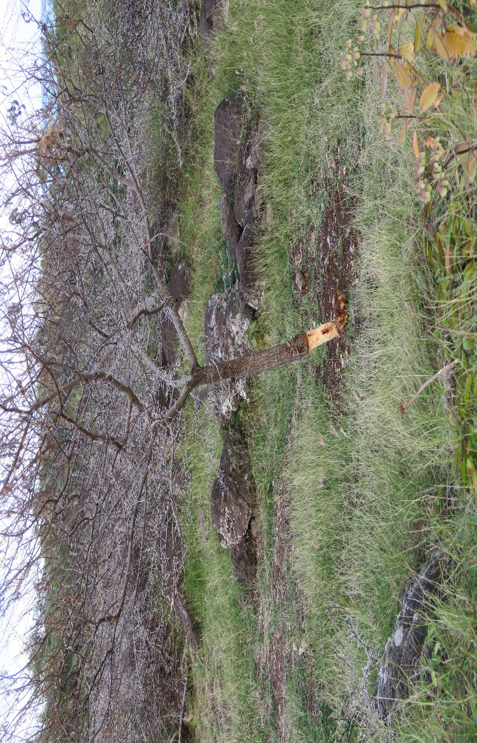

Additional Tips for Complete eradication of Invasive plants and minimising injury risk
- Manipulation of equipment and its associated possible risks.
Knowing how to handle an equipment is the way in reducing risk of being injured. Good or prudent manipulation/handling of equipment like chainsaw, blade and axe are essential in minimizing risk of being injured.
- Use branches and small trees for reinforcing security
Branches and small trees can be used to make natural fence. This will minimize the risk of being wounded with the branches and small trees.
- Application of ring barking techniques on juvenile plants
To ensure complete elimination of invasive plants, one must perform regular control of seedlings and remove them when they are small. 