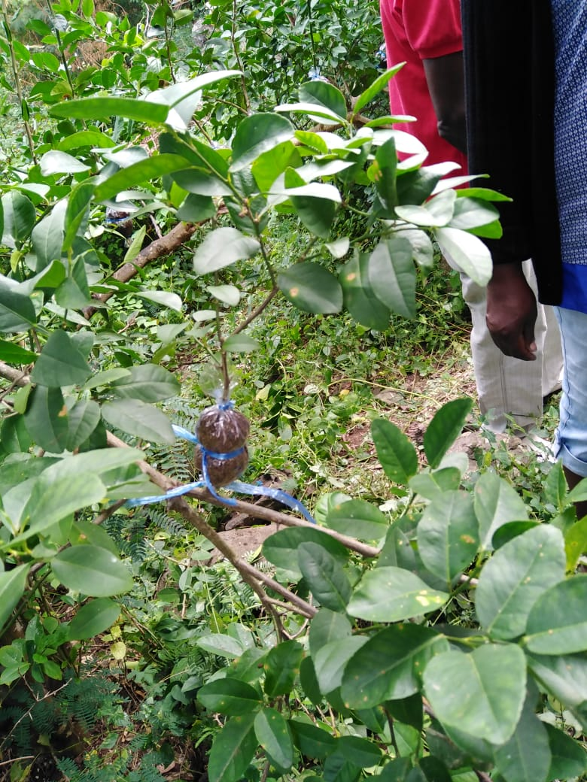
Introduction
This Toolkit presents the Guidelines on Nursery Management and Plant Propagation Techniques, showing how to manage a nursery and some techniques of plant propagation. A nursery is considered as a place where plants are being grown for sale. You are invited to use the Toolkit for yourself or for conducting group training.
This toolkit is being developed for those who are willing to embrace the path towards green ecological practices to discourage the use of chemical pesticides and other chemicals.
Utility of the toolkit
The toolkit shall act as a guide in setting direction and providing details on how to practice Nursery Management and plant propagation. It shall be used to spread knowledge and knowhow about nursery management and plant propagation techniques.
This training kit is based on the learning of a natural environment friendly method of plant propagation and techniques for reducing water consumption in plantation. The toolkit encompass the key aspects for complete nursery management, plant propagation and Permaculture.
Equipment needed
In order for someone to successfully conduct this training or to practice ring barking techniques. The following equipment will be needed:
Equipment requirement for applying Provin Techniques
Sn | Equipment | Quantity
1 | shears | 1
2 | penknife | 1
3 | Transparent Plastic film | 1
4 | Rafia String | 1 roll
5 | Soil | One handful
5 | Safety Gloves | 1 pair
6 | Scissor | 1 pair
7 | Syringe | 1
8 | Rooting hormone | 100 gram

Defining the terms
What is Marcottage?
It is a method of propagation of woody plants in which a wound made in the bark of a shoot is covered with a layer of rooting medium and wrapped to retain moisture, encouraging new roots to form before the shoot is detached from the parent plant.

How to apply the Marcottage technique
Step in practicing Marcottage technique are as follow:
- Put on work gloves if necessary.
- Select an appropriate branch which is mature enough then clean the branch with the help of the shear.
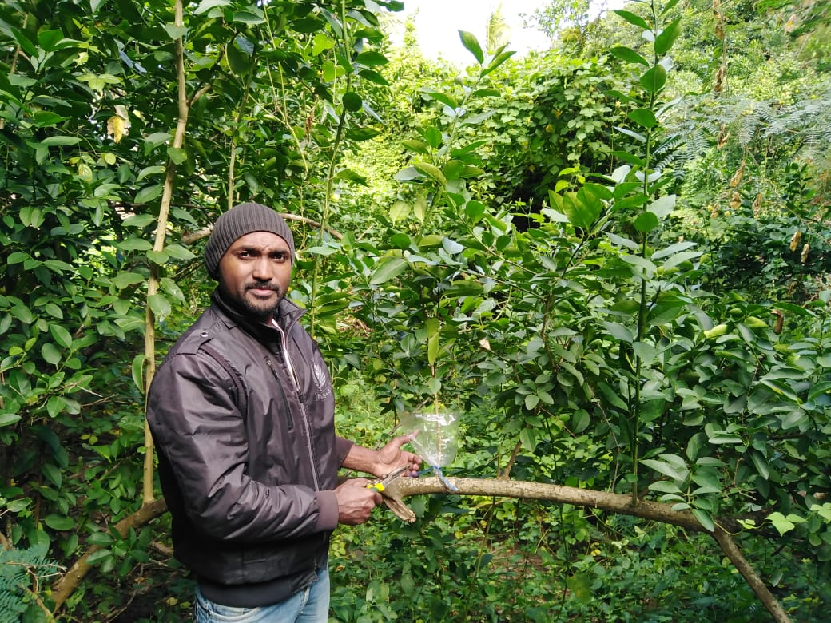
- Then after remove the bark of the branch approximately 1 inches apart around the circumference with the help of the penknife.
- Apply the rooting hormone on the branch where the bark has been removed.
- Then use the raffia string to tie the plastic so that it for a U shape. We then proceed by adding soil in the plastic forming the U shape. Do ensure that the soil completely cover the part of the branch where the rooting hormone was applied. Then use the scissor to cut a piece of the raffia string to tie the upper part of the plastic.
- Finally use the syringe to inject water into the marcottage sample.
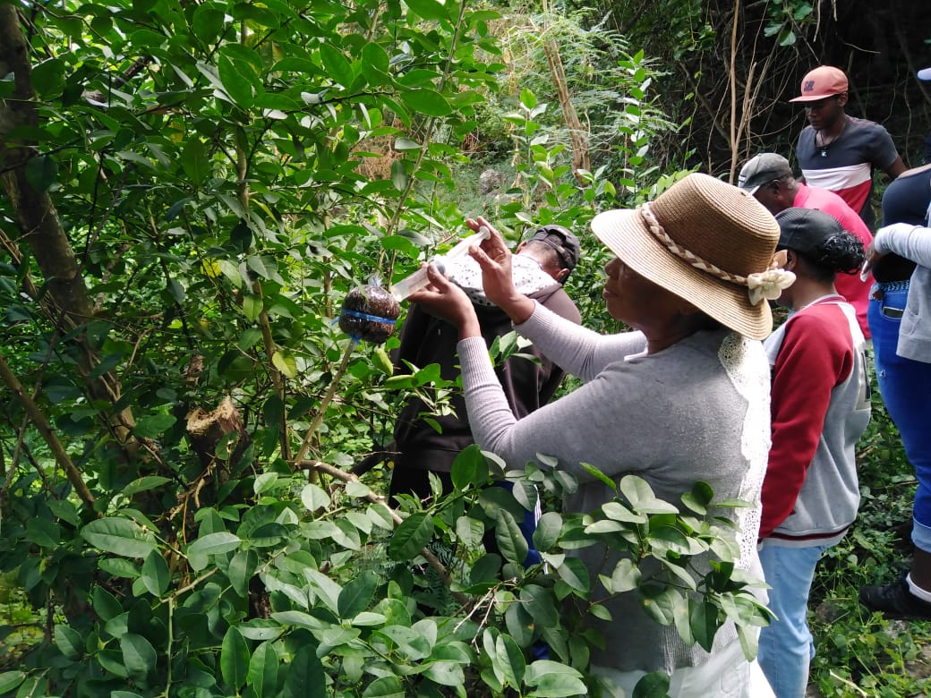
Permaculture
What is permaculture?
It is an agricultural system or method that seeks to integrate human activity with natural surroundings so as to create highly efficient self-sustaining ecosystems. In this training, accent was put on the way to reduce water consumption of plant by adopting technique that shall self-sustain water for the plant and reduce irrigation frequency.

Equipment needed
Equipment requirement for applying permaculture Techniques
Sn | Equipment | Quantity
1 | Shovel | 1
2 | Hoe | 1
3 | Fork | 1
4 | basket | 1
5 | Green and dry leaves and dry grass | One bag
5 | Safety Glove | 1 pair
6 | Pieces of woods | Several
7 | Serfouette | 1
8 | Cow dung | Appromixately 1 kg for one hole

How to apply Permaculture technique- Irrigation minimisation
- Use the serfouette to dig a hole of approximately 2*2 ft square. Remove all the soil and put aside the hole.
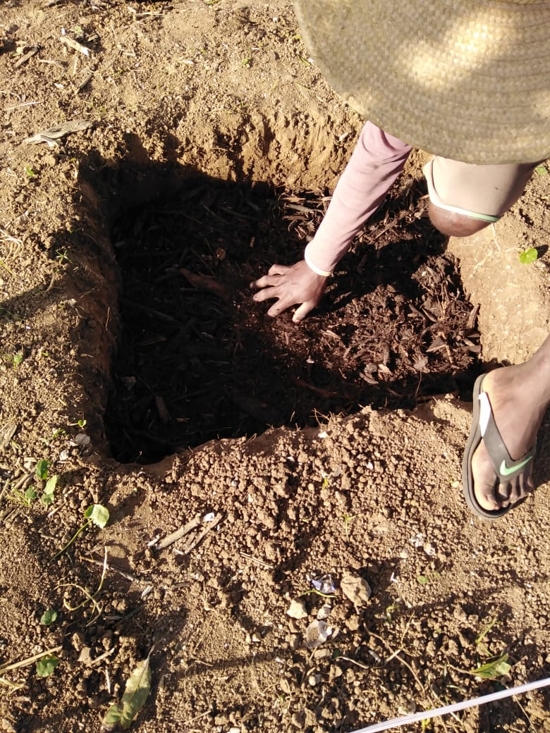
- Once completed, use some large size and small size pieces of wood and put in the hole.
- Then add some dry and green leaves and grasses together with a portion of cow dung if available.
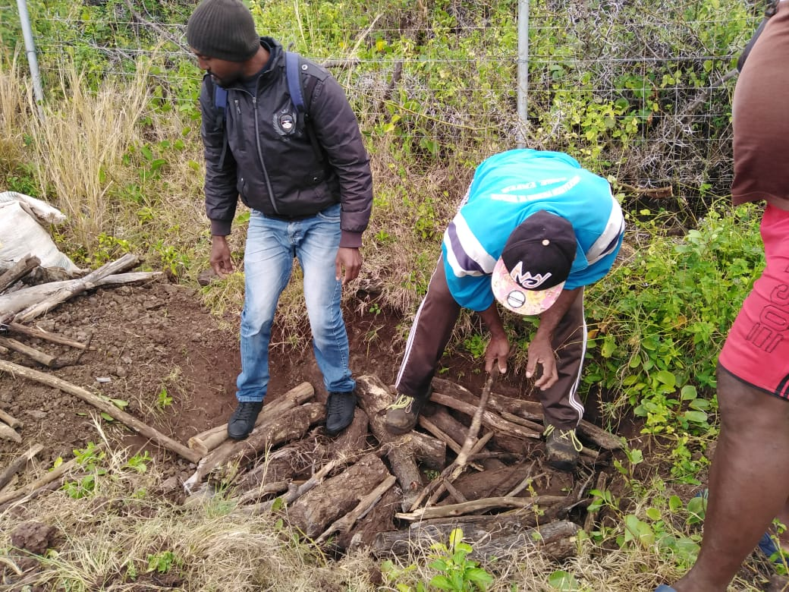
- We then add the soil which was removed from the hole mixed together with manure with the help of the basket.
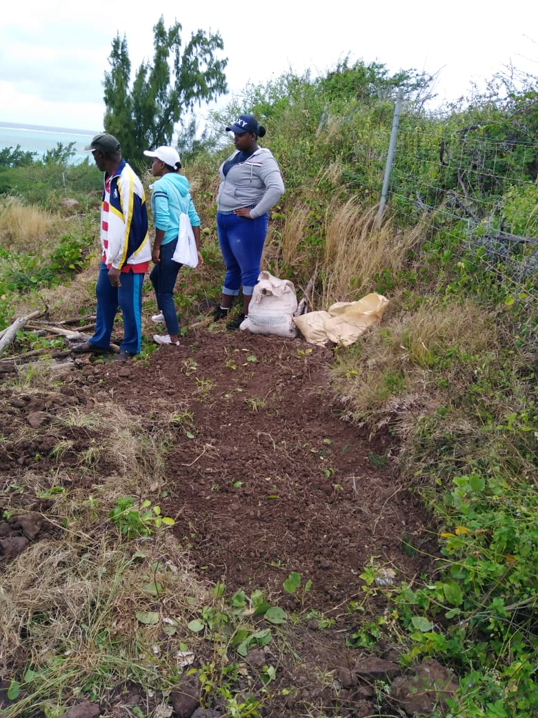
Then irrigate the hole and let rest for approximately 24 hours and then after we can proceed by planting in the hole.
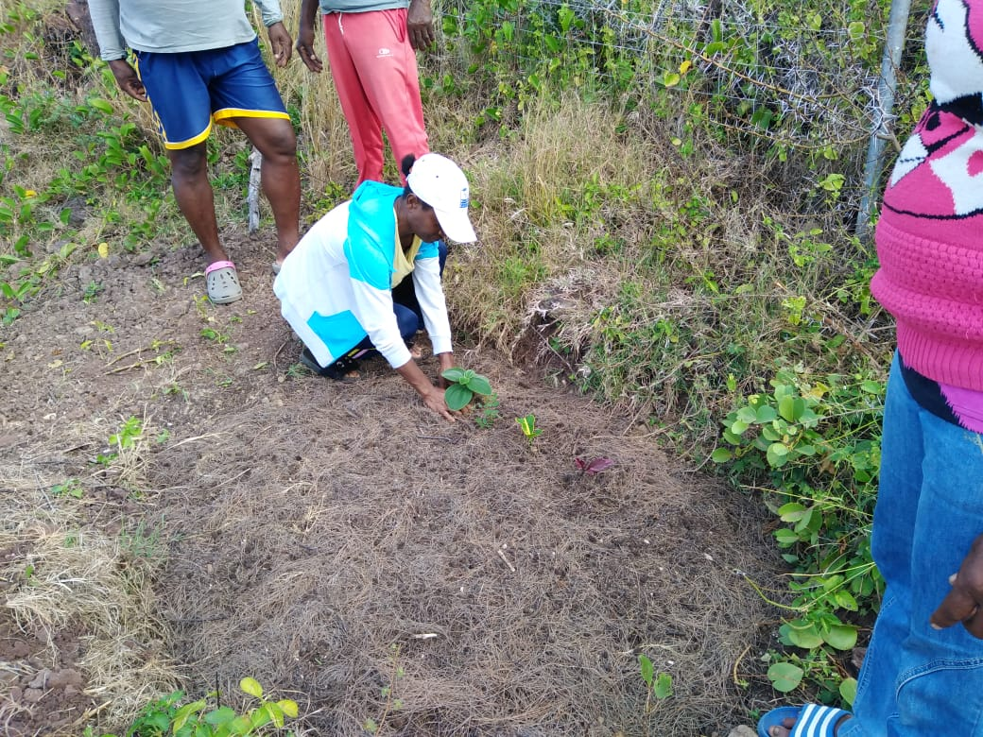
This technique can be used for reducing water consumption and irrigation frequency. Furthermore, it can be used for plant propagation technique named cuttings that is removing branches from mother plant and the remove its bark on approximately one inch or two inches. Then the same branches are being put in the hole and around approximately two to three days it starts to develop root.

The training also put emphasis on the maintenance of plant. The steps in maintaining a plant for healthy growth and higher productivity rate were elaborated as follow:
- To remove dry branches and also green branches to aerate the plant.
- Use a hoe to remove unwanted weeds and also adds some manure and dry leaves to maintain a certain level of humidity to the plant.
In addition further guidance were given on the nursery maintenance mainly on how to place the plants in the nursery, how to pot a plant, irrigation of seedling and mature plants. Advice were also given on how to embellish the environment and the market potential of ornamental plants and lemons.
Additional Tips for manure/compost making advice
Advice on how to make their own compost by using green leaves and dry leaves were also given.
